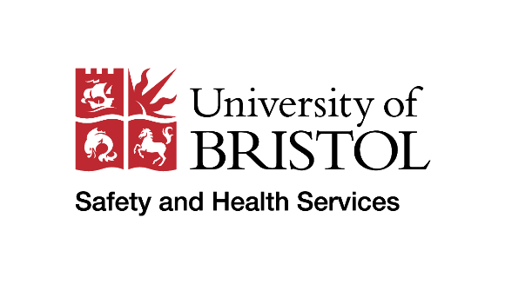
Risk assessment

Individual Risk Assessment

Employee details
Employee’s name |  | Job title
School/Service/Department |  | Line manager
Date of assessment |  | Review date

Ensure you have read
and understood the
following guidance before
starting the assessment.
Introduction

This risk assessment holistically assesses individual staff risk with the aim to safeguard University staff at most risk of adverse or serious reactions to infectious diseases or respiratory illnesses based on any emerging data and evidence. It not only considers clinical risk factors but also provides the opportunity to identify mental health-related factors, such as stress and anxiety.

We are asking line managers and colleagues falling into the categories described below to carry out an individual risk assessment.

This risk assessment can also be used to identify individuals experiencing mental health concerns relating to infectious diseases or respiratory illness. These concerns should be discussed with the line manager and details can be recorded in the corresponding section. Support from HR is available where necessary. Please note that if an individual highlights they are experiencing work-related stress, they should complete, with line manager support, the work-related stress individual assessment and action plan. Further advice on work-related stress is available from Safety and Health Services.

We also ask you to look again, very closely, at the health vulnerabilities of individuals. This risk assessment should involve a meaningful conversation and exploration of the risk factors.

Where there is agreement that the risk factors can be mitigated to everyone’s satisfaction, no change is needed. However, where it is clear there are increased risks for a colleague, the line manager must provide support and make necessary adjustments to mitigate those risks. HR and Safety & Health Services can provide advice and support to the line manager and colleague in identifying an approach that supports the individual.

The government advises people at increased risk of severe illness from infectious diseases to be particularly stringent in following social distancing measures. This group includes those with underlying health conditions listed below (anyone instructed to get a flu jab as an adult each year on medical grounds):
- pregnant
or have a long-term condition such as:
- a heart problem
- a chest complaint or serious breathing difficulties, including bronchitis, emphysema or some people with asthma
- a kidney disease
- lowered immunity due to disease or treatment (such as steroid medication or cancer treatment)
- liver disease
- had a stroke or a transient ischaemic attack (TIA)
- diabetes
- a neurological condition, such as multiple sclerosis (MS) or cerebral palsy
- a learning disability
- a problem with your spleen, such as sickle cell disease, or you have had your spleen removed
- you are seriously overweight (BMI of 40 and above)

Risk assessment process
1. Identify  the hazards | 2. Who might be harmed and how? | 3. Evaluate  the risks | 4. Record  your findings | 5. Review regularly
Potential exposure to infectious disease or respiratory illness. | See categories listed above | Greater risk of severe infection from Infectious diseases or respiratory illness  Greater risk of picking up a virus and being subject to severe infection from infectious diseases or respiratory illness  Temporary change of environment that may not accommodate previously recommended adjustments.  Have they received their Flu vaccination or COVID-19 booster or any other relevant vaccinations? | What can be done to remove or lessen the risk?  - Can the employee adhere to universal precautions that are already required to reduce risks of cross infection?  - Can they safely wear a face covering or PPE?  - Are there other roles which could be undertaken that may not involve working on campus?  - Can they move to a lower risk area?  - Can they work from other buildings?  - Can they work from home?  What additional actions can you take? | Assessments should be reviewed at least every 2 weeks, to take account of any actions taken since the previous risk assessment.

If the individual is experiencing stress, anxiety or other mental health related concerns, please add notes here. Examples might include concerns relating to returning to campus, vulnerable members of within the household or commuting to work.
Please note: If an individual feels they are they are experiencing work-related stress, the individual work-related stress assessment and action plan should be completed. Further guidance on work-related stress is available from Safety and Health Services. Support is also available from HR.

Agreed outcomes
Discussion notes and agreed outcomes/adjustments
- Confirm mutual understanding of why the risk assessment was needed and check understanding of risks, referring to the detail on page 2.
- Talk about risk factors and scores from page 4 and explore what that means.
- Talk about and explore any concerns or issues concerning the suggested actions. If the staff member still insists on working, please fully document and clearly state the reason why the staff member insists on staying in work and escalate to your HR Business Partner.

- Agree next steps.

- If there is any doubt in relation to a declared or known health condition/s, please contact your HR Team to arrange a referral to the University’s Occupational Health Service.

Please note: As health and demographic risk data gets further refined, scores and actions taken will need to be reappraised.

Declaration of understanding
I confirm the information in this risk assessment reflects our conversation and the agreement reached:
Line manager’s name
Date
Employee’s name
Date

Please note that this is based on the COVID-19 Risk Reduction Framework developed by NHS England

